|  |  |  |
| --- | --- | --- |
| **شعار جامعة بنها الجديد**f |  | **logo.jpg** |
| Benha University |  | Faculty of Computers & Informatics |

***Clinic Management System***

*Project Team*

***1. Ahmed Mohy Abd El Azeem Younis***

***2. Eslam Zakrya Ragaa Ibrahim***

***3. Eslam Hamdina shehata Abd el-lateef***

***4. Eslam el sayed Abd el Wahab Abdallah***

***5.Ahmed Mohamed Mohamed Salah***

**Discussion Committee:**

____________________________________ ________________

Date

____________________________________ ________________

Date

____________________________________ ________________

Date

***Abstract***

The main objective of this project is to manage patient details and facilitate access, appointments, and treatments. It manages all the information about the patient, appointments, and treatments. The entire project was built at the administrative end, thus only ensuring the administrator access. The purpose of this project is to build an application program to reduce the manual work of patient management, appointments, and treatments. It tracks all the details about the patient, appointments, and treatments.

**Program Interface**

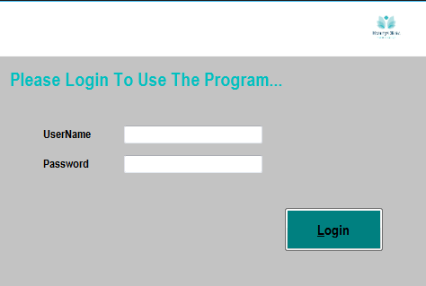 Program forms

**Login Form**

When the program run .this is the first form for the program. the user should be enter username and password to Use the program and press Login….

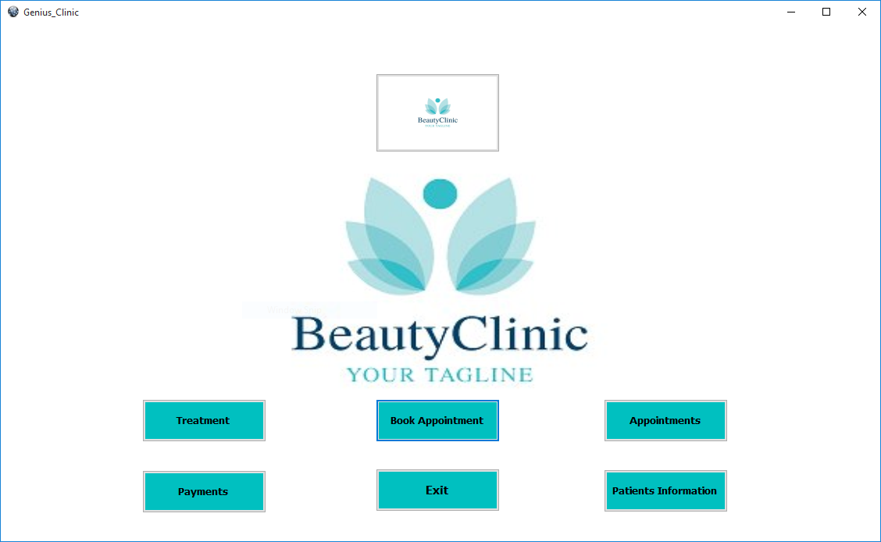

**Home Page Form**

When the user login, this screen will be appear. In this main screen there are seven buttons. Button for treatment , Book appointment , appointments , Payments , patient information, button in above and exit.

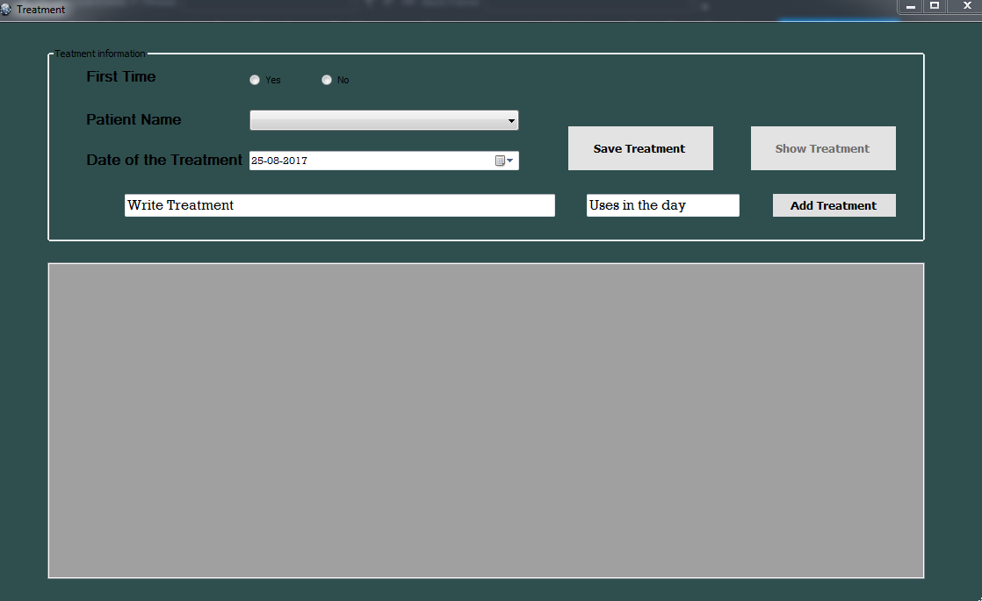

**Treatments Form**

When user press treatment in main screen , this screen will be opend . this form have three buttons,they are save treatment to save treatment data, show treatment it is allowed when it is not the first time to the patient ,it show treatments and add treatment to add current treatment data to a file .

this screen carries treatment information. The patient must answer on this questions. He must enter his name and answer if that is his first time or no . if this is first time , patient must enter his name. else the program provides registered names . user can write treatment and how many times it should be taken in the day . when user click save treatment , this data will be saved in a file.

**Book Appointment Form**

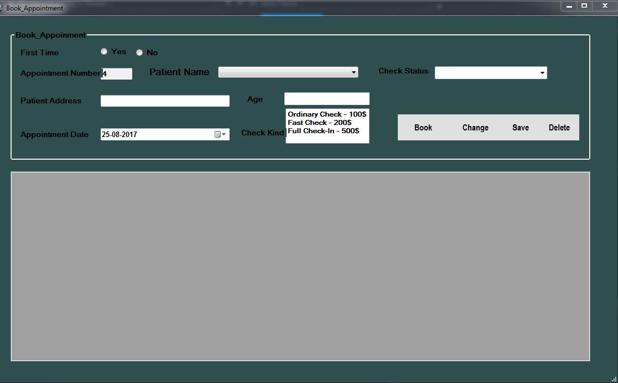

This form has four buttons. Button for book which send data to the list box , change to change data , save and delete to add and remove data from the file. This form contain patient informatiom, number of patient , name , age , check status , patient address , appointment date and sort of check . If this is first time , patient will be enter his name. else user can choose the name of patient from combo box.

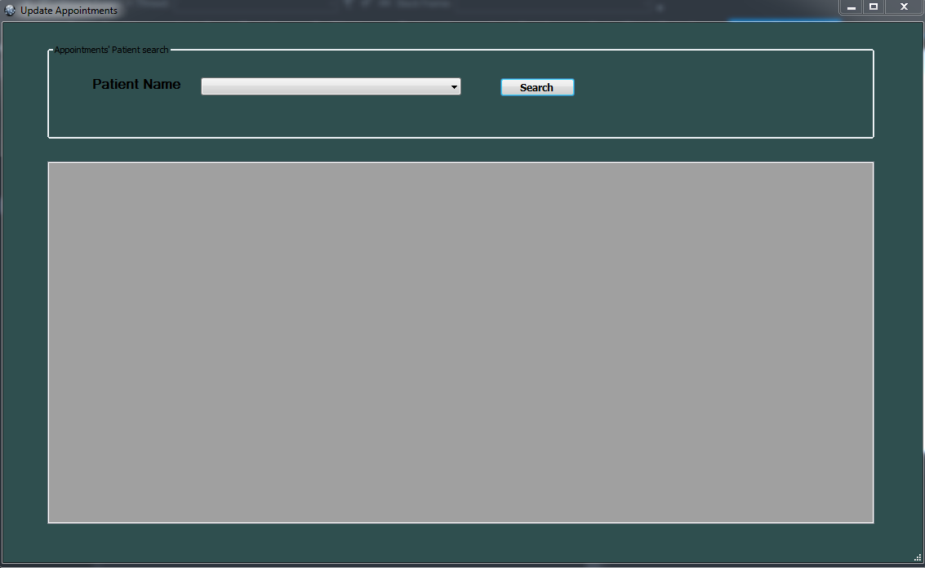

**Update Appointment** **Form**

This form can be used to search for any patient information. User can enter patient name and press search . his information will be shown in this textbox.

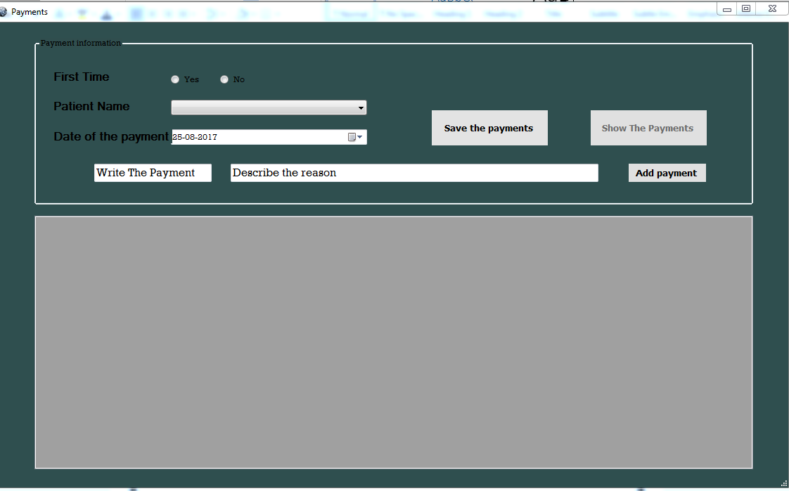**payments Form**

In this form , the money paid by the patient stored and the reason for payment ,if it is his first visit the button show the payment will be unenabled,If not he can see the previous payments and also add new payments.

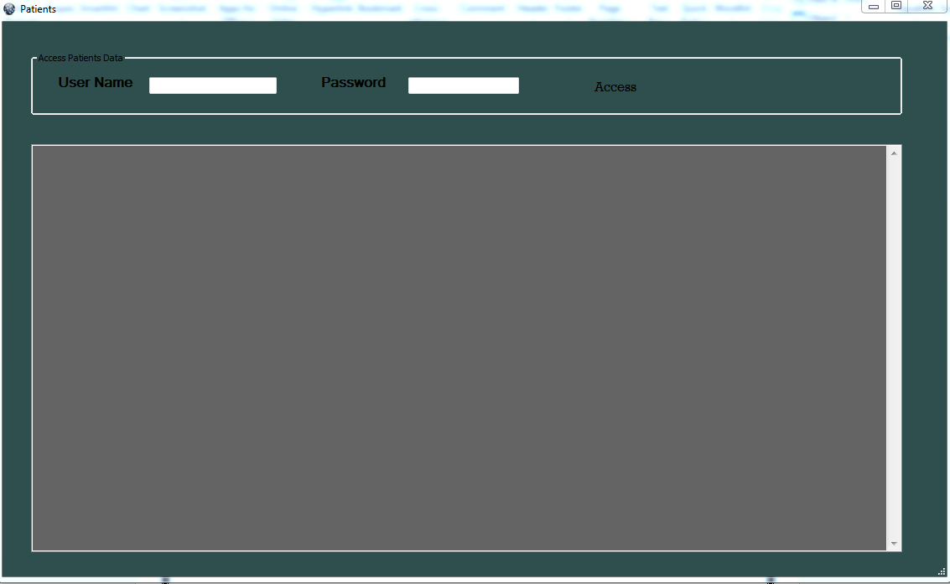

**Patient Information Form**

This form enable user to access data of any patient.user should enter name and password to access any data ,after this the program will show informations about all patients which stored in the file .

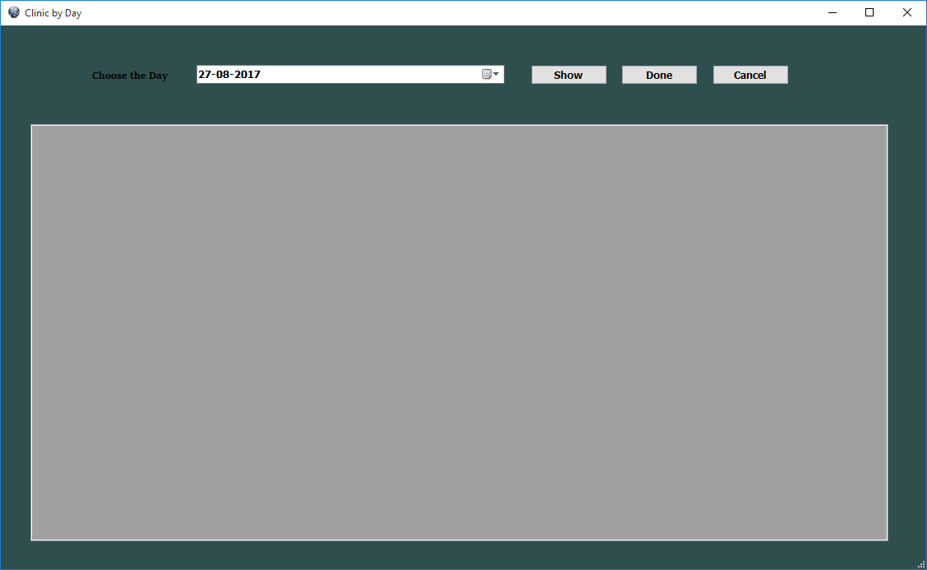

Clinc By Day Form

This form shown when user click on the button at the top of home page form .it has three buttons , show .when user choose a day and click show it displays all the patients informations in that day on the list box .done it puts that data in a file . cancel which enable user to remove the selected data in the list box from the file .

**Improvements and Extensions**

**The program can then be developed to receive patient's radiographs by scanner and print them. The program can also be developed to write patient status reports and save them in their data as well as to put the treatment according to diagnosis.**

**Difficulties Encountered**

One of the difficulties faced by the project is that if the assistant doctor searches for a patient by name, the program will stop.

It is also difficult to change the patient's number automatically as soon as a new patient is saved.

These problems have been addressed by searching through the Internet and consulting some engineers.

**Conclusion**

One of the most important points in this project is that it works to help the doctor and enable him to access the patient data easily and reduce the rate of error.

**Project Codes**

Home Page Form :

Button :



Code :

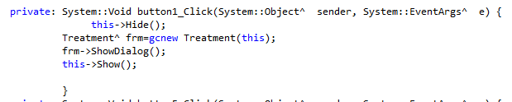

Button :

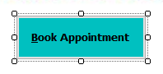

Code :

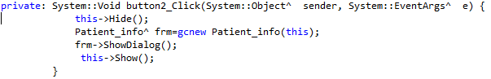

Button :

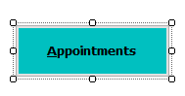

Code :

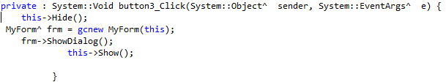

Button :

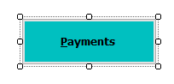

Code :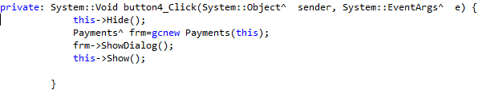

Button :

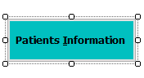

Code :

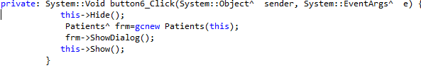

Button :



Code :

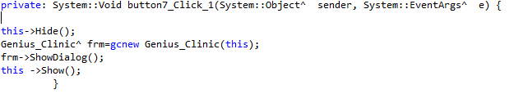

Button :

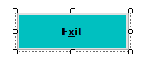

Code :

